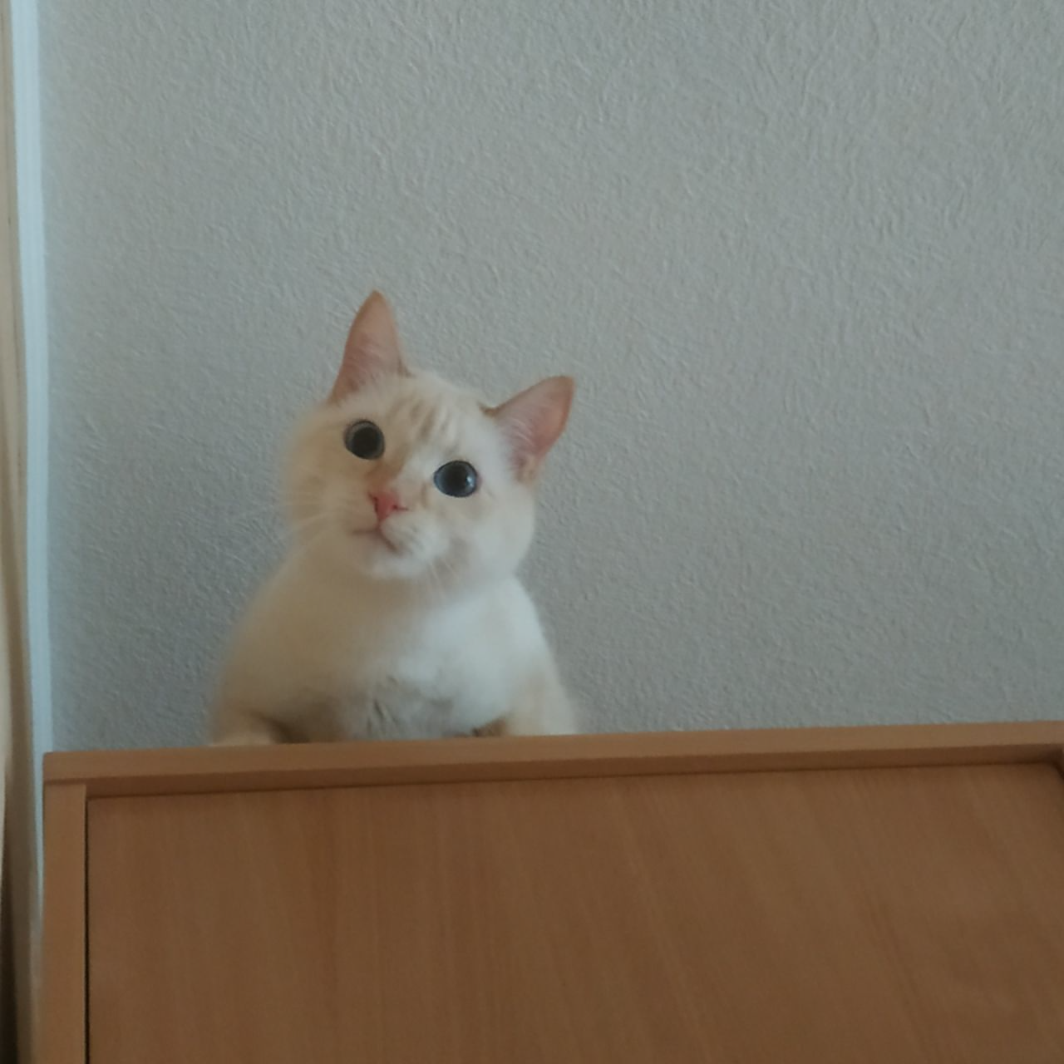

This is one of my favourite photos. It’s a picture of my cat. I took this photo one evening when I was at home with my family in the living room.

In the photo there is my cat Stiv. He sit in his favourite place and looks down on me. a safe home environment allows him to think about something.

I like this photo because my cat looks very interested and cute. It moment reminds me of relaxing evenings without work and time when I can play with my cat. This time always gives me good memories and feelings.

